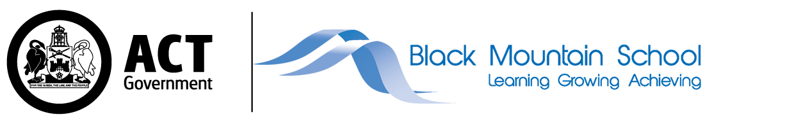
Dear parent and carers,

As promised, I am writing with additional information about the return of students to our school. campus. First, a reminder about the dates for our phased return.

Commencing 25 October  (Week 4) | - Years 9, 10, 11 and 12
Commencing 1 November  (Week 5) | - Years 7 and 8
From weeks 1 to 4 of term, onsite supervision and care continues to be available for vulnerable children and young people whose parents are essential workers.

Drawing on national and local health advice we have developed a return to school plan which has three key priorities:
- the health and safety of staff and young people,
- the mental and emotional well-being of students and staff, and
- ensuring continuity of learning.

Below is an outline of ACT Health Guidelines that schools are required to implement to ensure effective COVID-19 measures are in place.
Use of Check in CBR app | All staff and visitors must check in using the ‘Check in CBR' app. Parents and carers cannot enter school grounds except for an essential reason. Visitors must call to make an appointment, or in advance of attendance. All visitors must report to the front office.
Student illness | Staff and students who are unwell are not able to attend school. Students who present unwell will be required to go home.
Hygiene | Schools will maintain and promote appropriate hand hygiene and respiratory hygiene practices. Students will need to wash hands and use hand sanitisers throughout the day. Students will not be allowed to share food or drink.

Masks | Masks may not be suitable for students with a disability or medical condition and Black Mountain School will make allowances for those students not to wear masks.  Staff and all visitors must wear a face mask at school.  Students at Black Mountain School are encouraged to wear a mask if they are comfortable doing so.  * Students will be required to wear their personal masks. Masks will be available at school for those who require them. Disposable masks need to be changed every four hours.
Physical Distancing | Physical distancing between young people is not always possible, particularly in single classrooms and school environments. It is however important for limiting the transmission of COVID 19. To promote physical distancing, we may adjust learning programs, breaktimes, our timetable as well as pick up and drop off arrangements. More specific information about what this means for your young person is included below.
Environmental cleaning | Our school cleaning program includes regular cleaning of high touch services, frequently used objects, and play equipment.
Ventilation | All schools have been assessed to increase fresh air circulation and this may involve changes to ventilation, modified HVAC system settings and maximising the use of outdoor learning spaces.
Managing suspected cases | We are prepared to respond to a positive COVID-19 case at BMS, should the need arise. ACT Health will provide direction to the school and community, which may result in a full or partial school closure. A student who presents with symptoms of COVID-19 will be isolated with suitable supervision, and parents will be required to collect their child. Symptomatic students at Black Mountain School will be encouraged to wear a mask.
Will schools have routine testing for COVID-19? | Anyone with COVID-19 symptoms should get tested immediately. ACT Health is not recommending routine COVID-19 testing of children, young people  or staff using rapid antigen testing.
Wellbeing supports | For parents and carers of students with a medical vulnerability: if you wish the school to make reasonable adjustments for the safe return of your child, you must consult a GP and provide medical advice to that effect. Where adjustments can’t be made, the school will support your child to learn from home.

To further support the ACT Health Guidelines our school is making the following adjustments.
Drop off and pick up | Please see the attached map for drop off and pick up locations.  Buses:  We are working with Special Needs transport to ensure a staggered drop off and pick up. This will minimise the number of students entering and exiting the school at the same time. In addition:  - Special Needs Transport will continue to drop off and pick up students from the Faunce Cr entrance.  - Students will disembark one bus at a time and will enter the school according to their cohort (see below for cohorting details). This same process will apply for departing school in the afternoon.  Parent/Carer drop off pick up:  - The Faunce Cr entrance is available for Parents and Carers to drop off and pick up students.  - Students who usually enter through the Cockle St entrance will need to make arrangements with their class teacher for a staff member to meet you at the gate if arrangements are not already in place.  - As per the Health Guidelines families will not be allowed on school site at this time except in an emergency.  Please feel free to contact us if you have any concerns about your child’s drop off or pick up.
Hygiene routines | We will be following all ACT Health guidelines related to hygiene. There will be visuals around the school promoting the hygiene guidelines.  Masks and PPE:  - As per health Guidelines, mandatory mask wearing for staff will be enforced except where mask wearing causes distress to students, or a medical exemption is in place for the staff member.  - Students with disability are not mandated to wear a mask however, if you would like to discuss the option of your child being supported to wear a mask at school, please contact us.  - For toileting and feeding we require a mask, gloves, a disposable apron and if there is risk of splashing a visor, to be changed after each student.  - For HASS procedures, such as suctioning, surgical masks will be worn and if there is risk a coughing, a full gown, gloves and visor will be worn and disposed of after each student.  Hand Hygiene:  - Our staff will supervise students using hand sanitiser and hand washing.  - Hand sanitiser will be available in every classroom  - Hand sanitiser will be positioned in all entry and exit points at school  - Hand sanitiser will be placed in additional various locations around the school eg. front office, staff offices and photocopiers with appropriate signage to support students and staff.  - All students will be encouraged to access hand sanitiser or wash their hands before and after meals as well as before entering the classroom or exiting to the playground.
Teaching and learning | As a school, we have reviewed our class groupings and teacher cohorts to minimise the interactions between large numbers of students and staff. We have done this through adjusting access to shared spaces and limited the numbers of staff working across all class groups. The teaching program and individual education plans will be implemented as per normal with a focus on student wellbeing and engagement. To reduce risk and minimise interactions across cohorts we will be implementing a number of strategies including:  - Where possible we will be using outdoor spaces as part of our learning programs.  - Students will be grouped (cohorted) into learning teams Engage, Link, Compass and Connect.  - Each cohort will have assigned staff members, bathrooms and playground areas.  - Each cohort also has recommended routes through the school to limit the potential for multiple cohorts using the same space.  - Whole school events such as singing group will now be delivered online or to 1 cohort at a time.  - Assemblies and all whole school meetings will continue online.  - As staff have been assigned to a cohort, we will need to manage staff absences within the cohort. This may mean that at times classes will be combined.  Please see the attached map for further details.
Break times | Student break times will be modified to minimise the interactions between large numbers of students and staff. This will reduce the numbers of students on the playground at any one time. Where possible students will be using outdoor spaces. Visual timetables will be produced to support students to understand any changes to their daily program.  Class teachers will send out revised visual timetables by the end of week 3 (22 October) and will be talking to students in online meets about what school will look like for them over the next week.  Please see below for break times for each cohort:  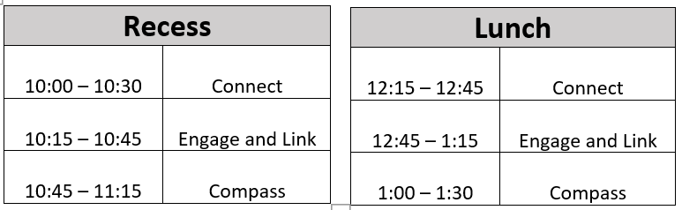
School canteens | As our canteen and café program are part of our learning programs, they will continue to run in a modified capacity.  Canteen:  The Foodie Friday canteen program and will implement a contactless delivery service.  Café:  The Six Degrees Café will operate as a take away service only and will only be open to school staff.

We will continue to review and adjust these measures based on the most up to date advice from ACT Health.
Remember, all adults and children aged 12 years and above are eligible for vaccination. If your child is eligible but not yet vaccinated, we encourage you to book them in by calling the COVID-19 vaccination line on 5124 7700 daily between 7am-7pm. Bookings can also be made with some GP clinics and pharmacies.
We understand that there has been considerable change and uncertainty for our students during the pandemic, and as we transition back to school. I’d remind you that you and your child can book an appointment with our Telehealth Support Service on 02 6205 1559 between 9.00am and 4.30pm weekdays.
For more information about the return to schools, I’d recommend visiting the Education Directorate’s website.
You can keep up to date with the latest health information, advice and resources on the ACT’s COVID-19 website.
I would also like to take this opportunity to thank you for your support and understanding as we return to face-to-face schooling.
We can’t wait to see all our students back at school.

My regards,

Kyrie Douch
a/Principal
Black Mountain School

